*Florida International University*

*School of Computing and Information Sciences*

INSTALLATION GUIDE

**Team Member:**

Ravi Kiran Agarthi

Shefali Nakum

**Product Owner(s)**:

Mohsen Taheri

**Mentor(s)**:

Masoud Sadjadi

Fransisco Ortega

**Instructor**: Masoud Sadjadi

# 

# 

**Installation Guide:**

1. Install Node.js using <https://nodejs.org/en/>
2. Install MongoDB using <https://www.mongodb.com/>
3. After Installing both, Download the code folder to the local system.
4. Create a folder “data” in C drive

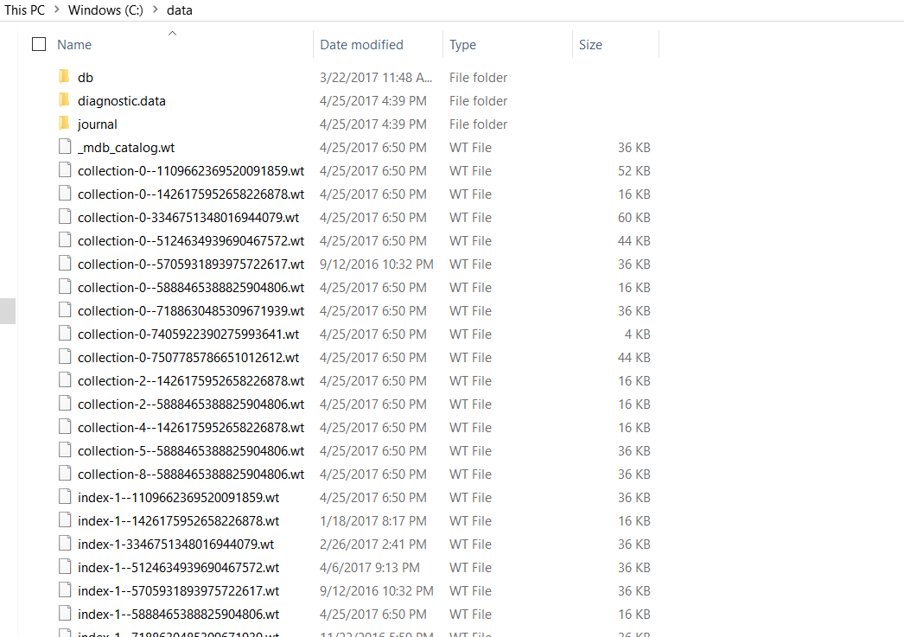

1. Go to the mongodb folder which is created in Program files after installation.
2. Run Mongod.exe with command line using the following command – mongod.exe –dbpath C:/data

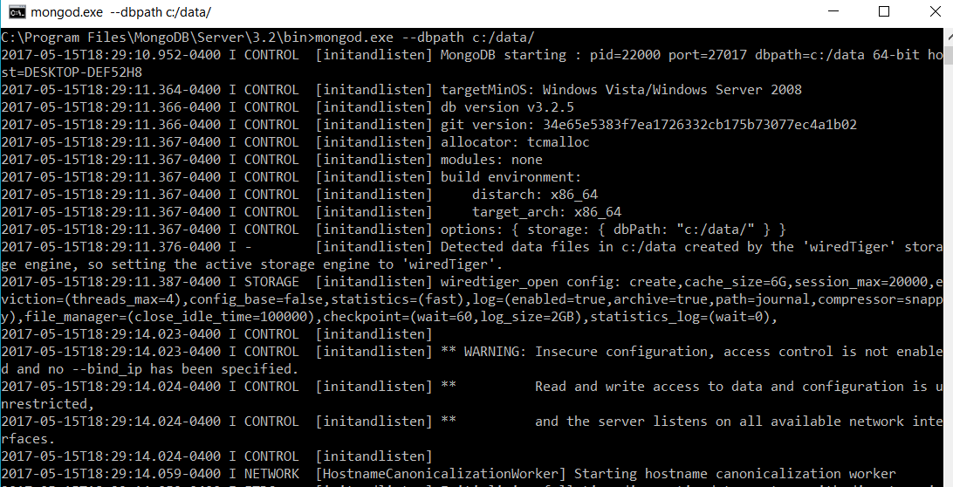

1. Run Mongo.exe with command line using the following command – mongo.exe

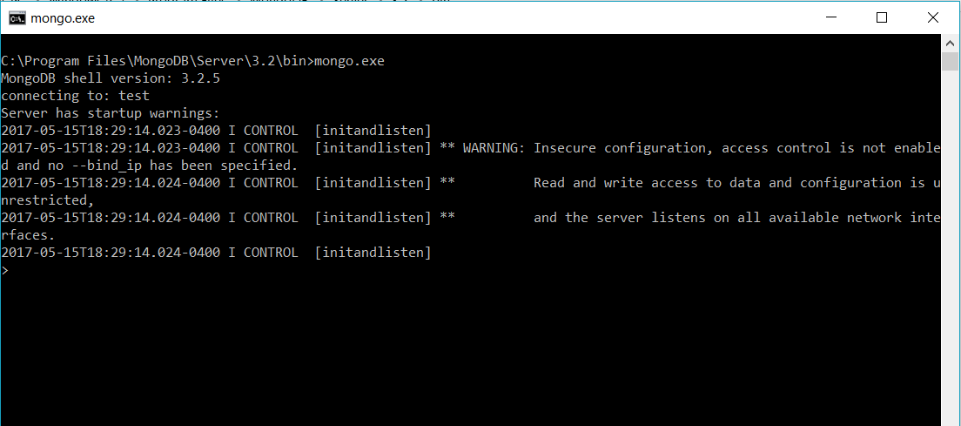

1. Now open the code folder and open the command line and run the following command – node server.js

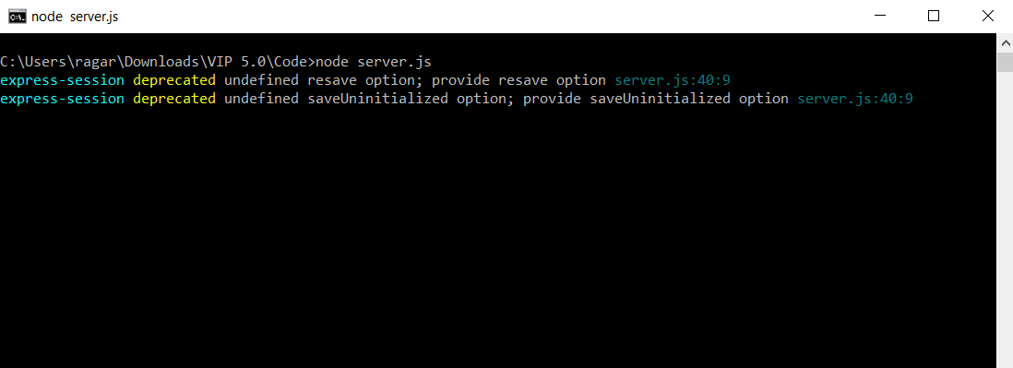

1. After that open any browser and type localhost:3000 to view the application.

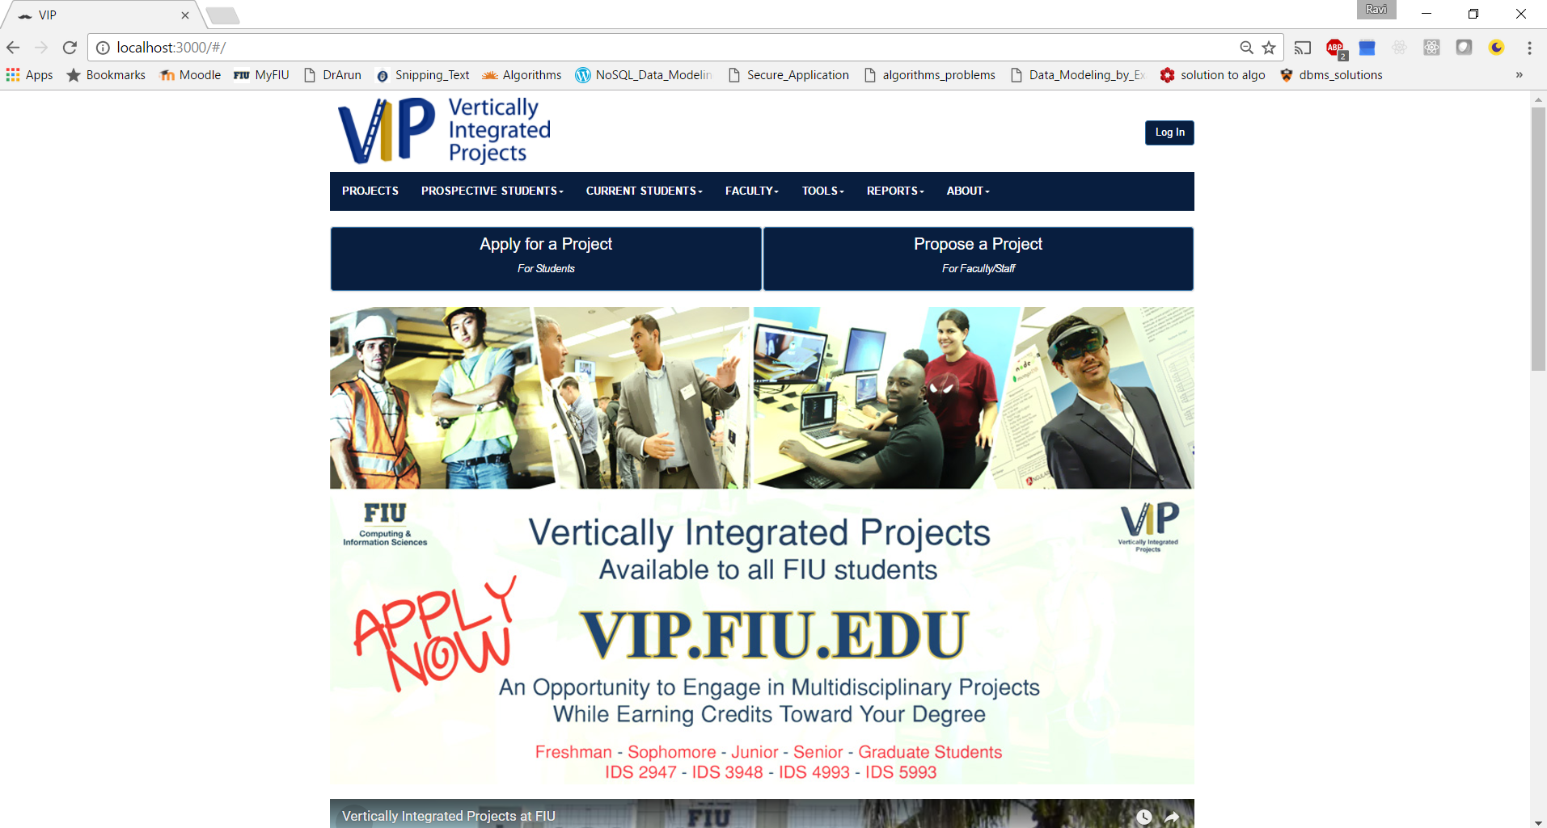

**DEPLOYING in VIP server**

1. Install Winscp using <https://winscp.net/eng/download.php>
2. Install Putty using <http://www.putty.org/>
3. After Installing Open Winscp
4. Enter vip.fiu.edu and give port as 22

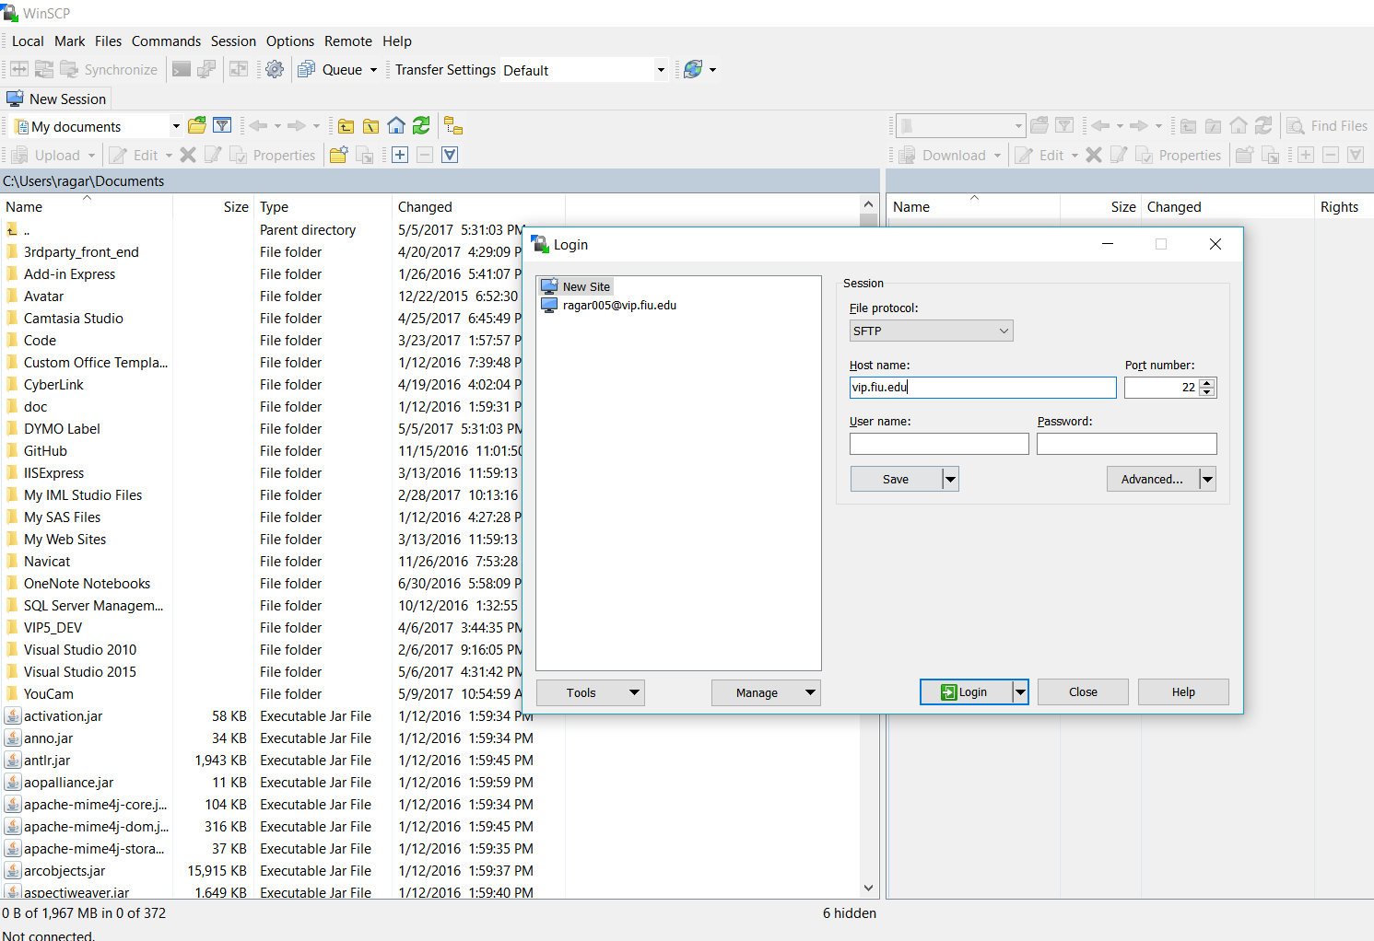

After login you will be prompted to enter username and password

Username is fiu email id without @fiu.edu

Password is <first letter of first name>Panther ID<first letter of last name>

After that you will find the code at this file path

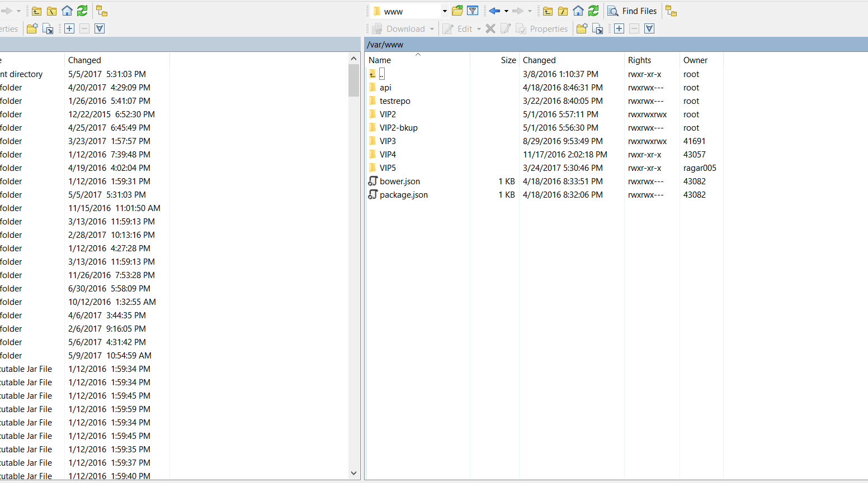

Now Open Putty and give the same address vip.fiu.edu with port 22 and same username and password

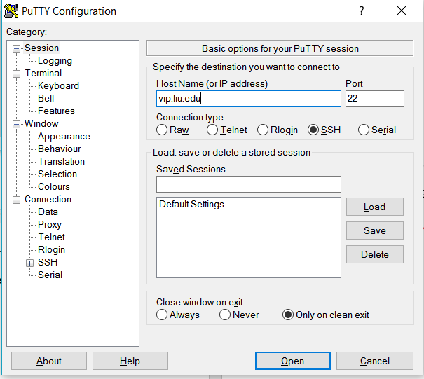

* Type sudo su to make yourself a root user
* And type password again
* Once you became a root user go to the same file path which we saw in winscp
* You can give command forever stopall to stop the instance of the server or forever start server.js to start a new instance of the server